DevelopersHub Corporation
Software Quality Assurance (SQA) – 3 Week Project
Week 3 Tasks
Automation Testing and Final Reporting
Project Title: Automation Testing and QA Final Report for Sweet n Swirl Application
System Under Test: SweetNSwirls – Android Ice-Cream Ordering Application
GitHub Repo Link Of Project: https://github.com/anam125/sweetnswirls
Student: Anam Saghir
Submission Date: 23 March 2026

1. Introduction
Week 3 focuses on learning automation testing and API testing concepts and preparing the final QA project report.
In previous weeks, manual testing, black-box testing, and compatibility testing were performed on the Sweet n Swirl Android application.
In this week, the following activities are performed:
- Learning automation tools
- Writing basic automation scripts
- Performing API testing
- Preparing final QA documentation

2. Introduction to Automation Testing
Automation Testing is a software testing technique in which test cases are executed automatically using tools and scripts instead of manual effort.
Advantages of Automation Testing:
- Saves time
- Reduces human errors
- Reusable test scripts
- Faster execution
- Improves efficiency

3. Tools Used in This Project
Two tools are used in this assignment:
1. Postman
Used for API Testing
2. Selenium
Used for understanding automation testing (conceptual)

. API Testing Using Postman
Since Sweet n Swirl uses SQLite (no real API), we use a dummy API:
https://jsonplaceholder.typicode.com
1. GET Request
Steps:
- Open Postman
- Select GET
- Enter URL:
https://jsonplaceholder.typicode.com/posts
- Click Send
Expected Result:
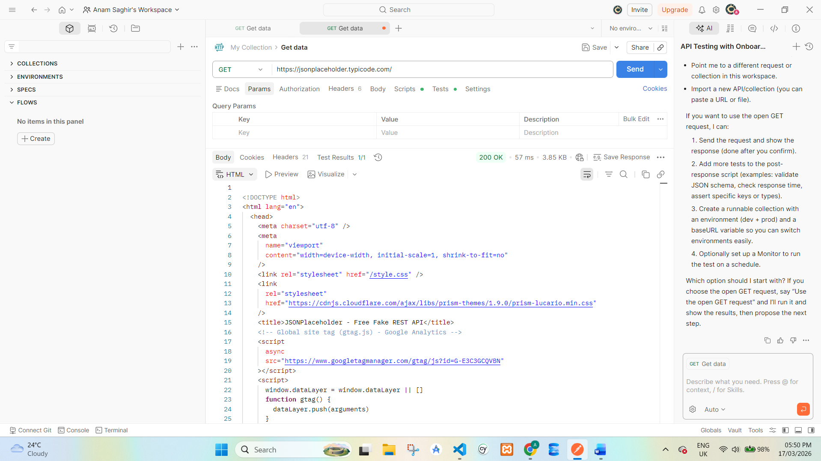
- List of posts displayed

2. POST Request:
Steps:
- Select POST
- Go to Body → raw → JSON
- Enter:
{
"title": "Ice Cream",
"body": "Vanilla Flavor",
"userId": 1
}
- Click Send
Expected Result:
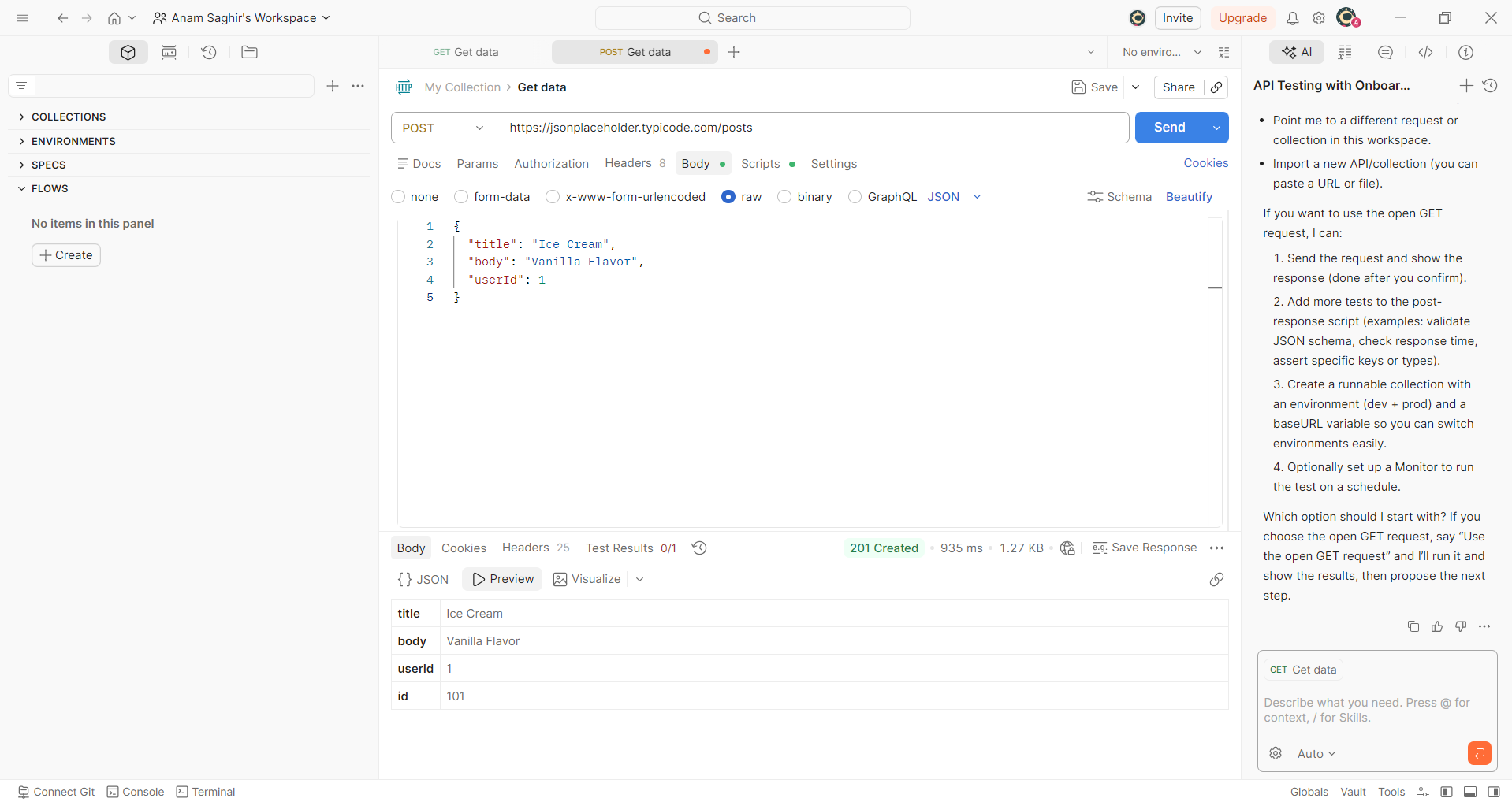
- New data created

3.PUT Request
Steps:
- Select PUT
- Enter URL:
https://jsonplaceholder.typicode.com/posts/1
- Add JSON body
- Click Send
Expected Result:
- Record updated
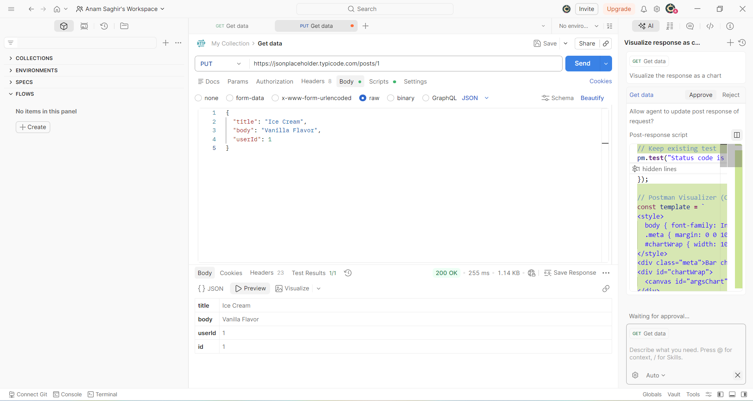

4. DELETE Request
Steps:
- Select DELETE
- Enter URL
- Click Send

Expected Result:
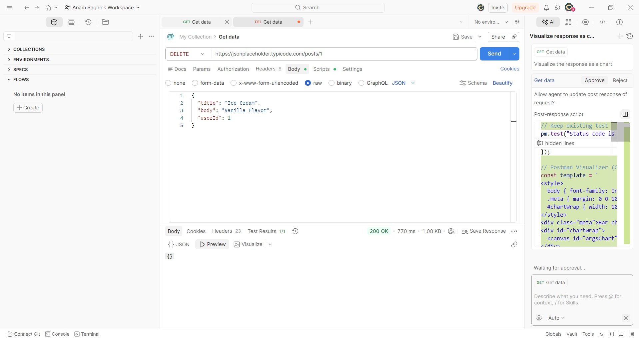
- Record deleted

